**CSCI 4734 – Machine Learning**

**Spring 2017 – Programming assignment-1**

***Linear Regression with one variable***

**Due date :** September 25th, 2017 (Submission through presenting working program after class is finished)

In this part of this exercise, you will implement linear regression with one variable to predict profits for a food truck. Suppose you are the CEO of a restaurant franchise and are considering different cities for opening a new outlet. The chain already has trucks in various cities and you have data for profits and populations from the cities. You would like to use this data to help you select which city to expand to next.

The file ex1data1.txt contains the dataset for our linear regression problem. The first column is the population of a city and the second column is the profit of a food truck in that city. A negative value for profit indicates a loss.

Given a single instance of a data set Ɗ with *m* instances, described by attribute *x*, and a class label *y*, build an iterative linear regression solver to find optimal *Ɵ* values as well as cost function.

Cost function J($Ɵ_{0},Ɵ_{1}$), that is defined as follows:

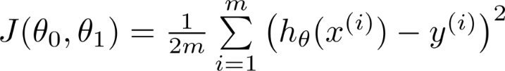

Write an application in your favorite programming language which takes the data file (data file is attached to the homework bundle), solves and prints optimal Ɵ, and the ***error (cost function)*** for the data set. Initialize Ɵs to be the ***zero***, and apply a gradient descent process, moving in the opposite direction of the gradient, with a learning rate of a constant factor α∈ℝ multiplied by the gradient at Ɵ.

And the update rule for Ɵ can be summarized as (update Ɵ after every iteration):

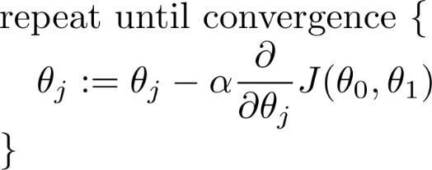

The number of iterations is 1500 and learning rate is 0.01. Also, your solver should print value of cost function and the values of parameters (thetas) in each iteration.

**Late submissions will not be accepted**, therefore, try to have at least a working baseline system by the deadline. Good luck.